**Appendix A:**

**Sample Demographics and Weighting Scheme**

|  |  |  |
| --- | --- | --- |
| Table A1  *Demographic Profile of Survey Sample and Target Population* | | |
|  | Current Survey | U.S. Census Bureau:  2016 American Community Survey | |
|  | (%) | (%) | |
| Gender |  |  | |
| Male | 49.0 | 49.2 | |
| Female | 51.0 | 50.8 | |
| Age (median) | 35-44 | 37.7 | |
| Ethnicity/race |  |  | |
| White | 59.6 | 62.0 | |
| Black or African American Native | 15.9 | 12.3 | |
| American Indian and Alaska Native | 1.5 | 0.7 | |
| Asian | 12.9 | 5.2 | |
| Native Hawaiian and other Pacific Islander | 0.2 | 0.2 | |
| Hispanic | 7.6 | 17.3 | |
| Household income (median) | US $60,000–75,000 | US $57,617 | |
| Education |  |  | |
| Less than high school graduate | 2.1 | 13.0 | |
| High school diploma or equivalent | 15.7 | 27.5 | |
| Some college or associate degree | 26.2 | 29.2 | |
| Bachelor’s degree or higher | 56.1 | 30.3 | |
| *Note*: The US Census Bureau 2016 American Community Survey is available online at http://factfinder.census.gov/ | | |

|  |  |
| --- | --- |
| Table A2  *Survey Weights* | |
| Income | |
| Category | Weight |
| Less than $15k | 1.02 |
| $15k to 30k | 1.00 |
| $30k to $45k | 1.00 |
| $45k to 60k | 1.00 |
| $60k to $75k | 1.00 |
| $75k to $100k | 0.86 |
| $100k to $150k | 0.95 |
| More than $150k | 0.95 |
| Education | |
| Category | Weight |
| None, or grades 1-8 | 5.75 |
| High school incomplete (grades 9-11) | 1.77 |
| High school graduate (grade 12 or GED certificate) | 1.33 |
| Some college, no 4-year degree (includes Associate’s Degree) | 0.89 |
| Technical, trade, or vocational school after high school | 0.65 |
| College graduate (Bachelor’s Degree) | 0.42 |
| Post-graduate training/professional school after college | 0.42 |
| *Note*. Income measured as annual household income. Education measured in terms of highest level completed. Final survey weights created by multiplying weights for income and education. | |

**Appendix B:**

**Full Results from Latent Class Analysis**

|  |  |  |  |  |  |
| --- | --- | --- | --- | --- | --- |
| Table B1  *Correlations Among Variables Used in Latent Class Analysis* | | | | | |
| Variable | 1. | 2. | 3. | 4. | 5. |
| 1. SM as News Source | 1.00 |  |  |  |  |
| 2. Self-Reported Interest | .34 | 1.00 |  |  |  |
| 3. Follow Accounts for News | .52 | .50 | 1.00 |  |  |
| 4. Algorithmic Categorization | .35 | .34 | .46 | 1.00 |  |
| 5. Social Curation | .40 | .41 | .72 | .41 | 1.00 |
| *Note*: Cell entries are Pearson’s correlation coefficients (*r*). *N* = 2,008. SM: Social Media. | | | | | |

|  |  |  |  |  |
| --- | --- | --- | --- | --- |
| Table B2  *Model Fit Statistics for Models with Varying Number of Latent Classes* | | | | |
| Model | AIC | BIC | *G*2 | χ2 |
| 2 Classes | 21,236.67 | 21,399.22 | 1,340.29 | 1,805.39 |
| 3 Classes | 20,613.65 | 20,860.26 | 687.27 | 902.79 |
| **4 Classes** | 20,428.18 | **20,758.87** | 471.80 | 720.57 |
| 5 Classes | 20,403.53 | 20,818.29 | 417.15 | 558.00 |
| *Note*: BIC was the primary criterion for model selection. The BIC is generally better than *G*2 or χ2 for establishing model fit, as these statistics almost always decrease when the number of classes increases, regardless of concern for overfitting. Additionally, the BIC typically outperforms the AIC for model selection, as it presents a stronger penalty for adding parameters (i.e., classes). *N* = 2,008. | | | | |

|  |  |  |
| --- | --- | --- |
| Table B3  *Predicted and Observed Latent Class Membership* | | |
| Latent Class | Predicted | Observed |
| 1: Low Attraction (*n* = 594) | .40 | .38 |
| 2: Medium Attraction—Unmotivated (*n* = 805) | .30 | .31 |
| 3: Medium Attraction—Motivated (*n* = 416) | .21 | .21 |
| 4: High Attraction (*n* = 193) | .10 | .10 |
| *Note*: Cell entries are predicted probabilities and observed proportions obtained from a latent class analysis (LCA) model. Column totals may not equal 1 due to rounding. *N* = 2,008. | | |

**Appendix C:**

**Test of Criterion Validity**

***Non-Social Media News Use***

Non-social media news use was measured with four survey items measured on 5-point scales (1 = *Never*, 5 = *Several times a day*) asking respondents how often they got news directly from the following sources in the past week: online websites for mainstream news; online-only news websites; print versions of newspapers; and broadcast or television news. These four items were averaged for each respondent (Cronbach’s alpha = .80, *M* = 2.6, *SD* = 1.1).

|  |  |  |
| --- | --- | --- |
| Table C1  *Differences in Non-Social Media News Exposure among the News Attraction Groups* | | |
|  | Non-Social Media News Use | |
| **Fixed Effects** | β | *SE* |
| Intercept (*M* Low News Attraction) | 1.86*** | 0.04 |
| News Attraction (Δ versus Low) |  |  |
| Medium—Unmotivated | 0.57*** | 0.04 |
| Medium—Motivated | 1.46*** | 0.05 |
| High | 1.98*** | 0.07 |
| Age | -0.01 | 0.01 |
| Gender (1 = Female) | -0.20*** | 0.04 |
| Race (1 = Person of Color) | 0.07* | 0.04 |
| Education | 0.06*** | 0.01 |
| Income | 0.05*** | 0.01 |
| Ideology (+ Conservative) | 0.00 | 0.01 |
| Party Identity (+ Republican) | 0.00 | 0.01 |
| **Random Effects** | *Var.* | *SD* |
| Intercept | 0.01 | 0.11 |
| **Fit Statistics** |  |  |
| ICC | .02 | |
| LL | -2,535.29 | |
| Pseudo-*R*2 | .52 | |
| *Note*: Cell entries are parameter estimates from linear multilevel model with random intercepts. Data are weighted by education and income. *N* = 2,008. Groups = 17. | | |

s

Figure C1

*Differences Among News Attraction Groups in Non-Social Media News Use*

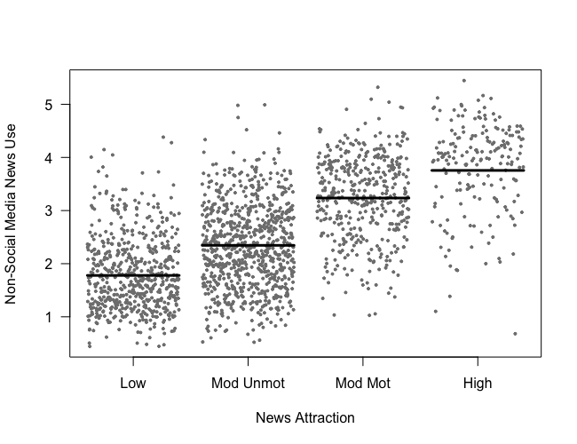

**Appendix D:**

**Additional Results from Regression Analysis**

|  |  |  |
| --- | --- | --- |
| Table D1  *Estimated Adjusted Means of News Engagement Among the News Attraction Groups by Exposure Type* | | |
| **Engagement** |  |  |
| Group | Purposeful | Incidental |
| Low | 4.11 | 1.44 |
| Moderate—Unmotivated | 4.88 | 3.71 |
| Moderate—Motivated | 5.45 | 4.22 |
| High | 5.93 | 4.98 |
| **High-Effort Engagement** |  |  |
| Group | Purposeful | Incidental |
| Low | 1.77 | 0.40 |
| Moderate—Unmotivated | 2.12 | 1.68 |
| Moderate—Motivated | 2.36 | 1.95 |
| High | 2.64 | 2.44 |
| *Note*: Cell entries are adjusted means estimated from multilevel models reported in Table 3. | | |

**Appendix E:**

**Demographic Differences Among News Attraction Groups**

Supplemental analyses show that each successive attraction group has higher levels of both education (*F* = 27.77, *p* < .001) and income (*F* = 35.48, *p* < .001), where all post-hoc tests (Tukey) differences between pairs of groups are statistically significant with at least *p* < .01. The difference between the low- and high-attraction groups is 1.21 for education (measured on a 7-point scale) and 1.76 for income (8-point scale). Further, there are significant differences in terms of race (χ² = 20.64, *p* < .001; Cramer’s V = .10) and gender (χ² = 71.95, *p* < .001; Cramer’s V = .19), such that people of color and women are less likely to be in the high-attraction group (26% people of color an 27% women) than they are in the low-attraction group (44% people of color and 58% women).

**Appendix F:**

**Self-Reported Interest as Sole Predictor**

To demonstrate this difference between the latent-class variable and self-reported interest, which is variable that has received the most attention both theoretically and empirically from prior literature (e.g., Barnidge, 2021; Thorson et al., 2021), we re-ran all regression analyses using only self-reported interest. Results are both less robust and less rich in terms of their descriptive capacity. Whereas our analysis of the latent-class variable revealed important and theoretically fruitful group differences in incidental exposure, self-reported interest is unrelated to the trait-like measure and only weakly related to the state-like measure (β = 0.12, *SE* = 0.05, *p* = .022).